DAILY ONLINE ACTIVITIES SUMMARY

Date: |  |  | 12/06/2020 |  |  |  |  | Name: | Suhas Prasad Shetty
Sem & Sec |  |  | 8th B |  |  |  |  | USN: | 4AL16CS080
 |  |  |  |  |  | Online Test Summary
Subject |  |  |  | BDA
Max. Marks |  |  |  | 30 |  |  | Score |  | 24
 |  |  |  |  | Certification Course Summary
Course |  |  | Network Ninja to Cloud Ninja
Certificate Provider |  |  |  |  | AWS |  | Duration |  |  | 30mins
 |  |  |  |  |  | Coding | Challenges
Problem Statement:Python Program to Remove Punctuations From a String
Status: Solved
Uploaded the report in Github |  |  |  |  |  |  | YES
If yes Repository name |  |  |  |  |  |  | suhas
Uploaded the report in slack |  |  |  |  |  |  | YES

Online test detail:

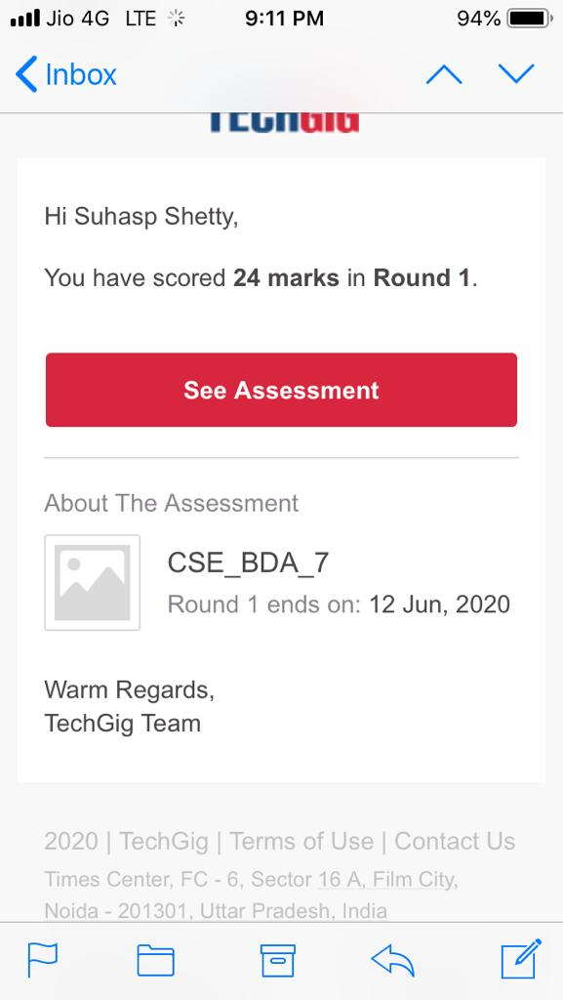

Certification Course Details:

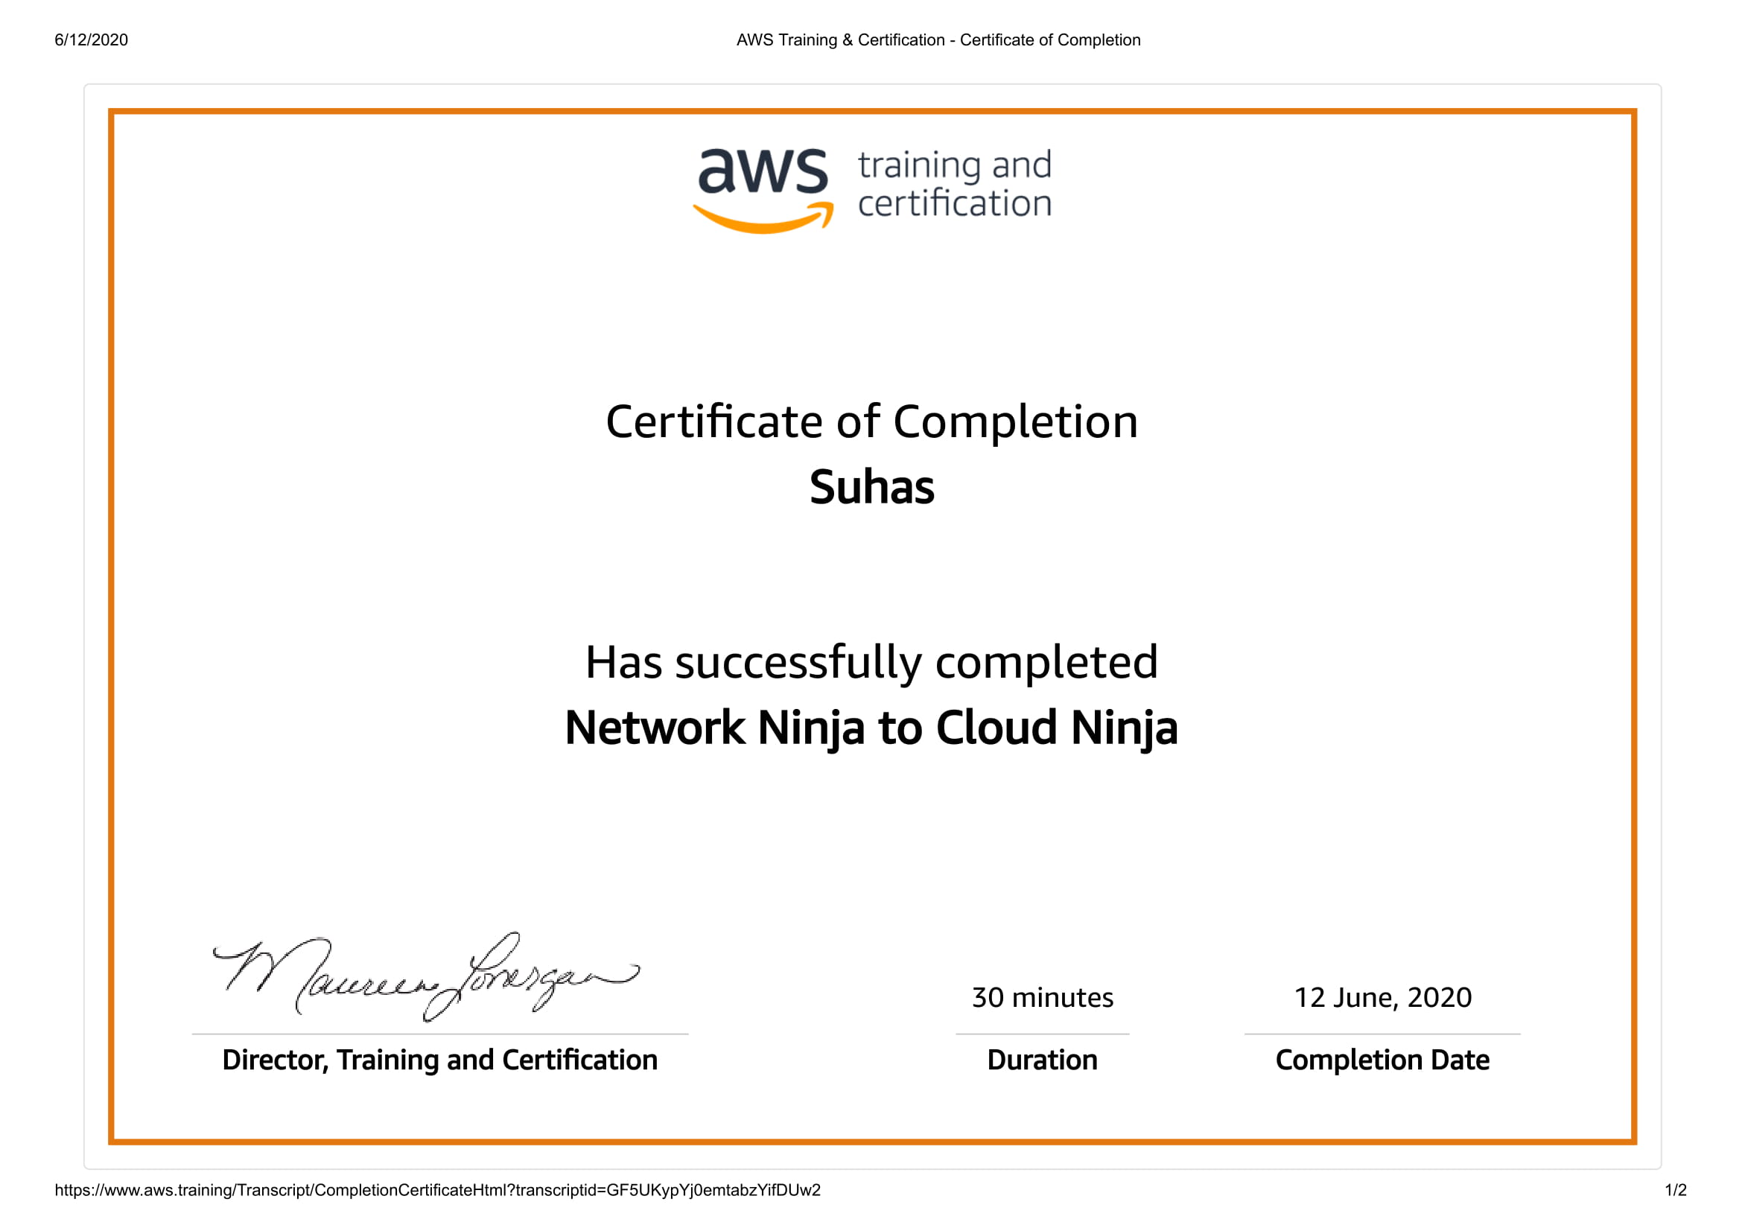

CODE:

Program no:1

punctuations = '''!()-[]{};:'"\,<>./?@#$%^&*_~'''

my_str = "Hello!!!, he said ---and went."

no_punct = ""

for char in my_str:

if char not in punctuations:

no_punct = no_punct + char

print(no_punct)

